**Formatting Guide**

You will have five kinds of reports you can choose to create:

1. Flashnote
2. Company Note
3. Initiation
4. Sector Note
5. Macro and Strategy

When you work on the template it is **imperative** that you work in **View Gridlines** mode. This will allow you to see exactly where your margins are and help when creating tables, charts, etc. You must be clicked in a table to see this button, but it is under the Layout tab.

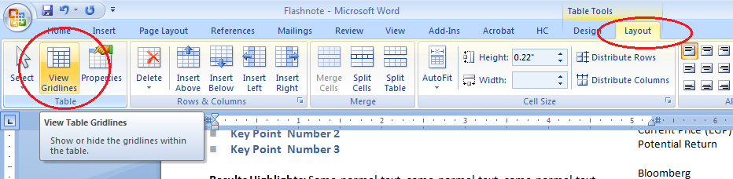

**Do not, under any circumstances, adjust the margins on ANY page of the template**. If your text does not fit, cut some. If your tables or charts do not fit, adjust them or ask your editor for help.

**All text in our template is Calibri**.

**Front page banner**

**Title text:** Company name, sector name, or country name. White, Calibri 36pt, not bold.

**Text on top left:** This is the type of report. It is white, Calibri 10pt, bold.

**Text on bottom left:** This is your sector/the country. It is white, Calibri 10pt, bold.

**Text on bottom right:** This is always MENA Research. It is white, Calibri 10pt, bold.

**Front page, body**

**Cover page section title:** Black, Calibri 20pt, not bold. This will be Title Case (see editorial guide)

**Bullets:** Blue, Calibri 11pt, bold, left aligned.

The text is the following blue

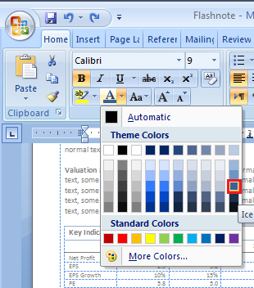

**Body text:**

* Black, Calibri 11pt.
* All text will be left aligned.
* First sentence of each paragraph is bolded.
* In earnings flashnotes, paragraphs will start with **Results Highlights, What We Think, Action, Valuation and Catalysts.**

**Key Indicator Table**

See table section.

**Front page, side banner**

**Recommendation:**

* Black, Calibri 20pt, not bold.
* The text is in a cell, sandwiched between two blue lines, which are 3/4pt width and the same blue as the bullet text. (Right click and click borders and shading to see this window)

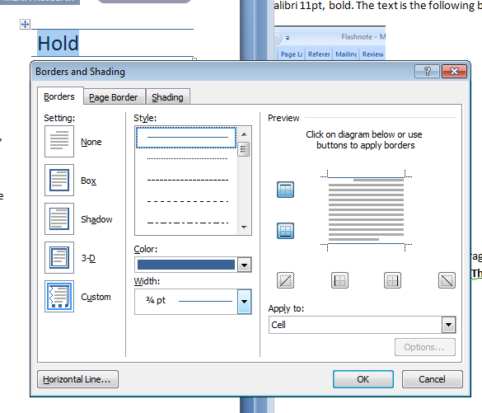

**Stock data box:**

* Target price is black, Calibri 10.5pt, bold.
* The rest of the data is black, Calibri 10.5pt not bold.
* The data on the right is right aligned; the data on the left is left aligned.

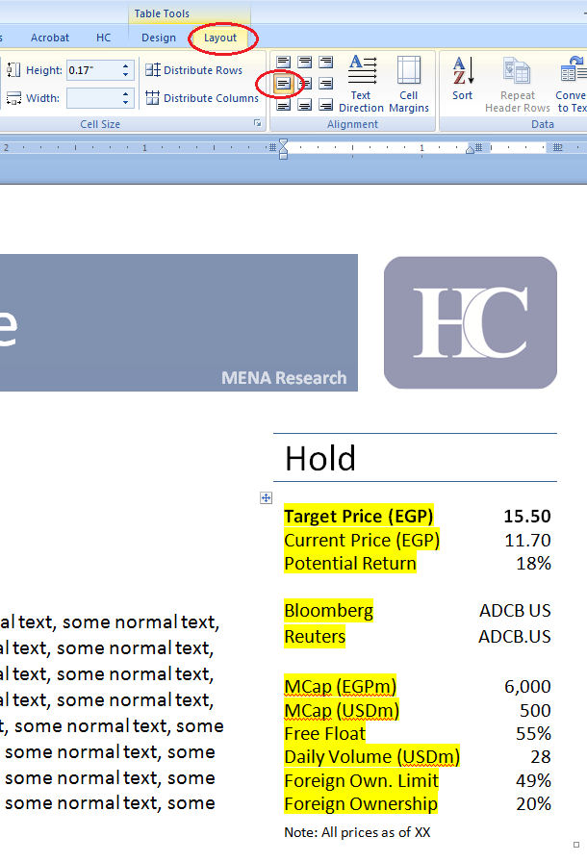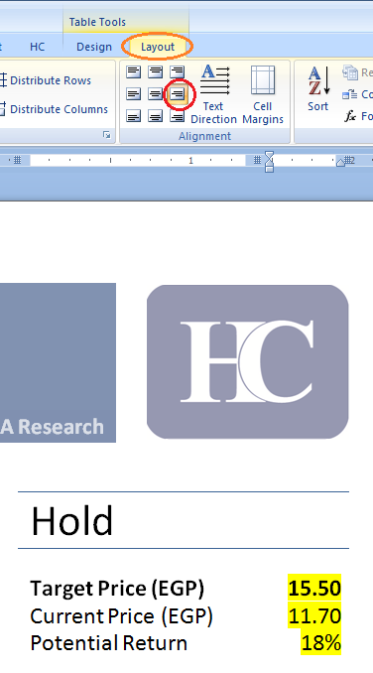

* The note is black, Calibri 8pt, not bold, and has 2pt line spacing above it:

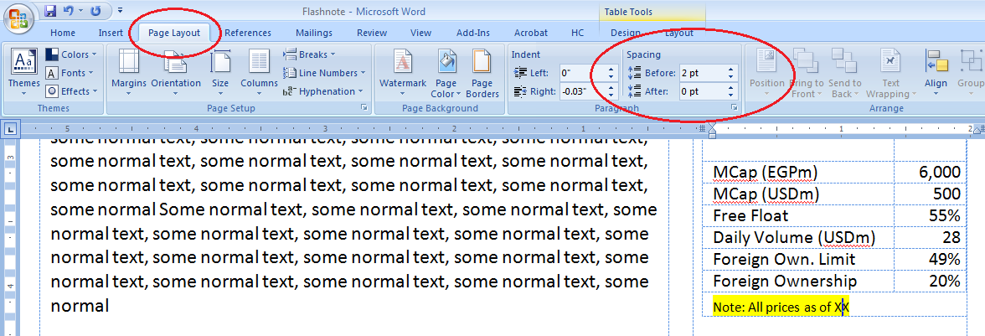

**Price Performance chart:** This is a regular chart (see chart section), but the headline is Calibri 10.5pt and the chart font is Calibri 6pt.

**Date:** Black, Calibri 12pt, bold, written in our standard date style (see editorial guide). The line spacing above and below the date is Calibri 9pt.

**Contact data**

* Contact name: Black, Calibri 11pt, bold.
* Analyst: Black: Black, Calibri 11pt.
* Phone number: Black, Calibri 11pt.
* Email: Black, Calibri 11pt.
* Spacing between contact data is Calibri 9pt.

**Disclaimer:** Black, Calibri 11pt, bold.

**Report headers and footers**

**Company Name**

**Sector | Country**

**24 August 2010**

Calibri, 9pt font, bold. The text is the following blue:



The line under the header is the same blue, 1½ pts

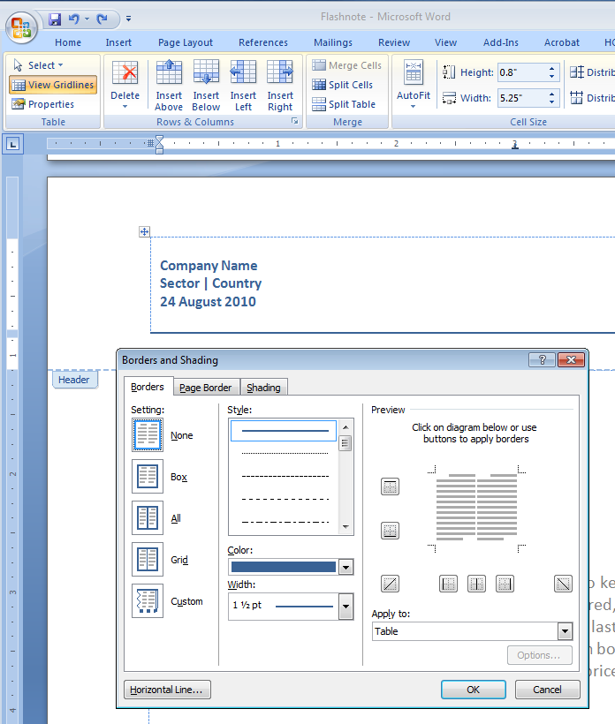

**Footer:** The report footer is just the page number, which will begin on the second page. It is black, Calibri, 9pt.

**Report body**

You will be writing your text in a table, so please use view gridlines to be able to see this table and make it easier for you to write. You may insert a text section in the HC tab under insert. You can add subsections, sub-subsections, and bullets also in from the HC tab but **make sure you add these while in the text table otherwise your margins will be incorrect.**

**Section Title:** Black, Calibri 20pt, not bold, title case.

**Subsections:** Black, Calibri 14pt, bold, title case.

**Sub-subsections:** Black, Calibri 11pt, bold, title case.

**Body text:** Black, Calibri, 11pt, left aligned.

**Side notes:** Black, Calibri, 10pt, right aligned.

**Bullets:** Blue, Calibri 11pt, bold, left aligned. The text is the following blue.



**Tables**

All tables have a **headline**, **top row**, **content**, and **source**. Some tables have **optional** qualities. To insert a table in the template, go into the HC tab under insert and type in how many columns and rows your table needs to have.

**Headlines:**

* Text is black, Calibri 11pt, bold, title case.
* It is sandwiched between two blue lines, which are 3/4pt width and the same blue as the bullet text, which you can see if you right click and click on borders and shading.
* The text has 2pt line spacing above and below, which you can see in the page layout tab.

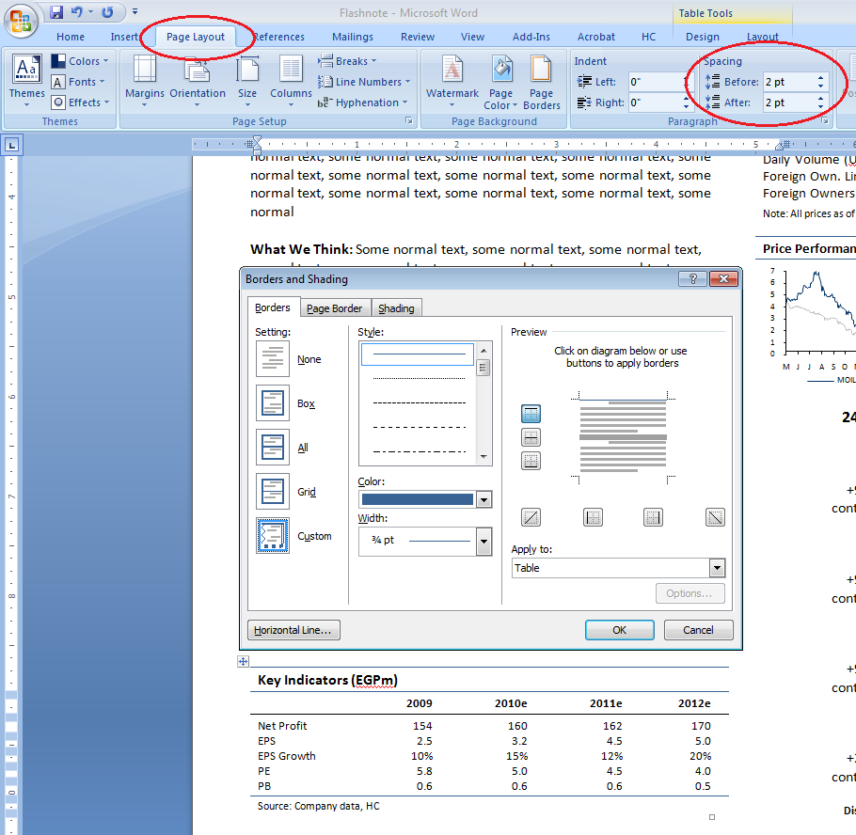

**Top row:**

* Text is black, Calibri 9pt, title case.
* It has a black line underneath it, which is 3/4 pt.
* The text has 2pt line spacing above and below, which you can see in the page layout tab.

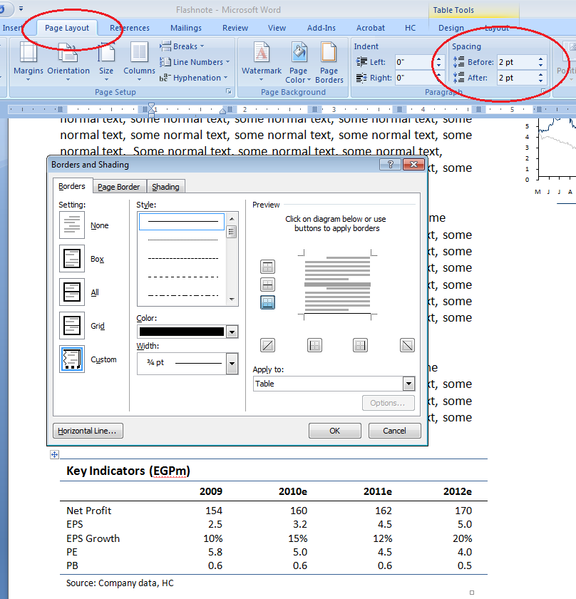

**Content:**

* Text is Calibri 9pt, title case.
* There are no borders within the table.
* The firsthand left column is left aligned. The rest of the columns are right aligned.
* The first row of data will have 2pt line spacing before and the last row of data will have 2pt line spacing after.

**Source:**

* Text is black, Calibri 8pt.
* Source will be followed by a colon then a space, then your source in sentence case.
* Do not write HC Research, HC Estimates etc. Use simply HC.
* The text has 2pt line spacing above.
* The source has a blue line above it, identical to the blue lines in the headline.

**Optional:**

* **Notes:** 
  + Notes in your table will be indicated by a superscript number in parenthesis in the header if it’s a whole table note, or near your value if it’s a specific note. The text is black, Calibri 11pt.
  + The note will go below the source in black, Calibri 8pt.
  + Note will be followed by a colon, then a space, then your notes in sentence case without periods between.

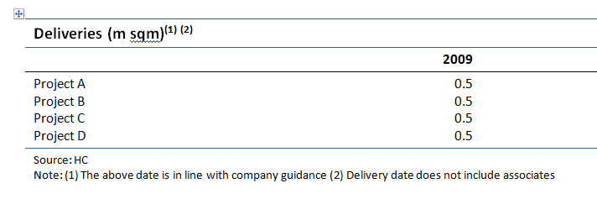

* **Optional gridlines:** 
  + Please do NOT use gridlines unless absolutely necessary. Before you jump to gridlines, consider if the information in would be better represented in a bulleted list.
  + If your table is genuinely hard to read, you can use 1/4pt gridlines in the second-lightest gray available.

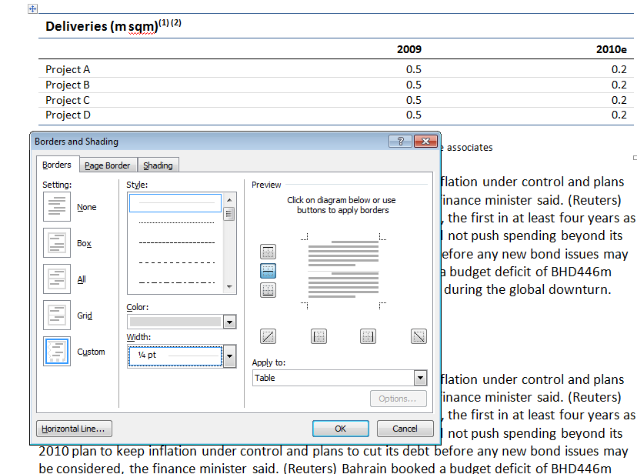

**Charts**

There are two types of charts: **side by side charts** and **single charts**. The difference between them is a separator, or lack thereof, between the headlines and sources. You can insert a bar chart, pie chart, line chart, dual pie chart, and dual bar chart from the HC tab under insert.

**Headlines:**

* Text is black, Calibri 11pt, bold, title case.
* It is sandwiched between two blue lines, which are 3/4pt width and the same blue as the bullet text, which you can see if you right click and click on borders and shading.
* The text has 2pt line spacing above and below, which you can see in the page layout tab.

**Source:**

* Text is black, Calibri 8pt.
* Source will be followed by a colon then a space, then your source in sentence case.
* Do not write HC Research, HC Estimates etc. Use simply HC.
* The text has 2pt line spacing above.
* The source has a blue line above it, identical to the blue lines in the headline.
* Please make sure that your table is not overlapping the bottom line as this will cause your line to disappear when it is PDFed.

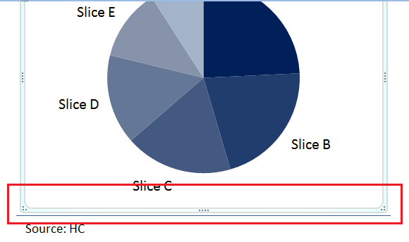

**Colors and design:**

* Please use **ONLY** the template colors and no others.

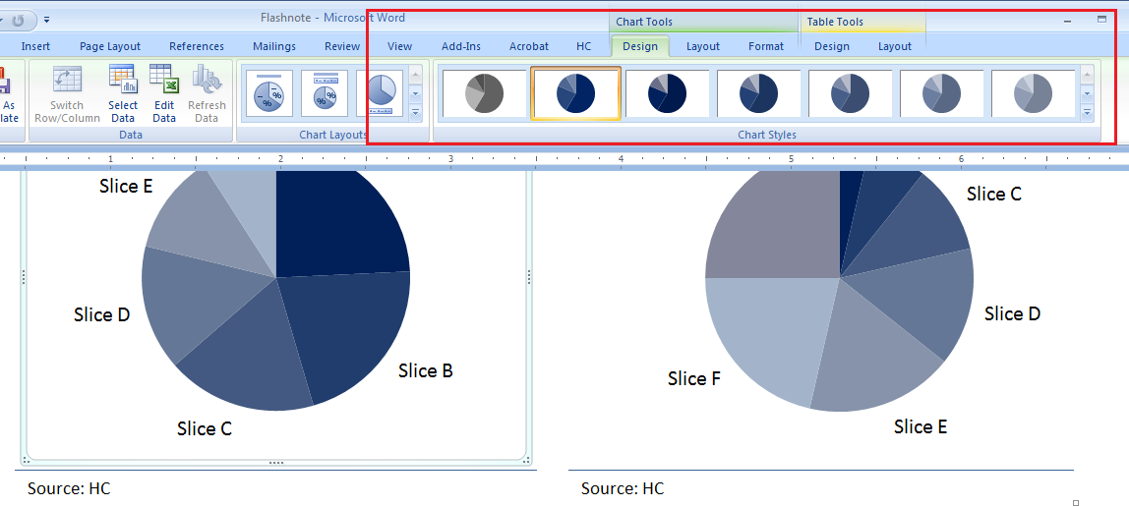

* Please use our darker blues and grays unless your chart is overly complicated.

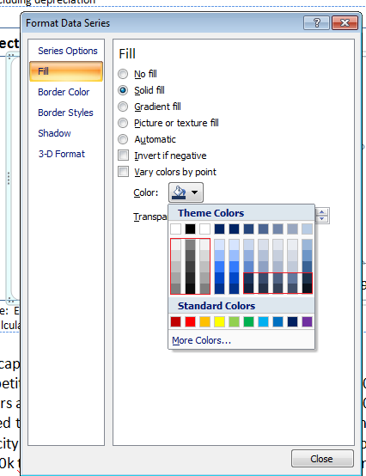

* Charts have NO gridlines.

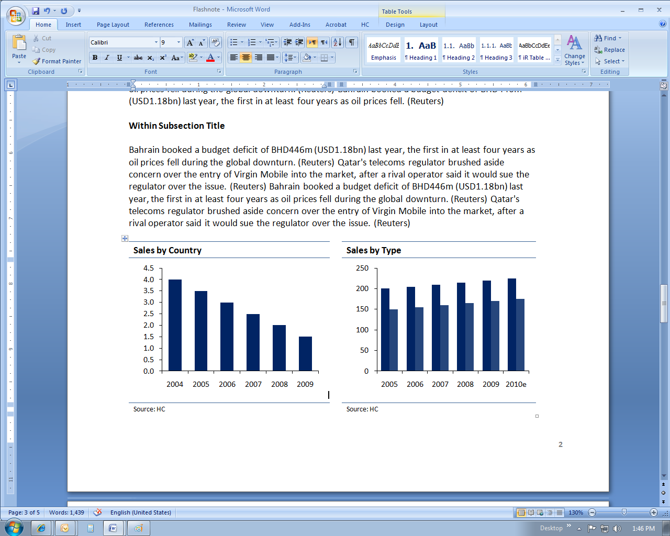

**Text:**

* Black, Calibri 9pt, not bold, title case.
* Legends will appear at the bottom of charts.
* Units will appear along the y-axis in the same font as the rest of the chart

**Optional:**

* **Notes:** 
  + Notes in your table will be indicated by a superscript number in parenthesis in the header if it’s a whole table note, or near your value if it’s a specific note. The text is black, Calibri 11pt.
  + The note will go below the source in black, Calibri 8pt.
  + Note will be followed by a colon, then a space, then your notes in sentence case without periods between.

